**How to Add User Access in Inventory System**

**STEP 1:**

See to it that the user had a company id number release by the Human Capital Department.

All users account should be define first in INVENTORY SYSTEM.

Log-In to Inventory System > Click Admin Tools Menu > Select User Account, see figure 1.0

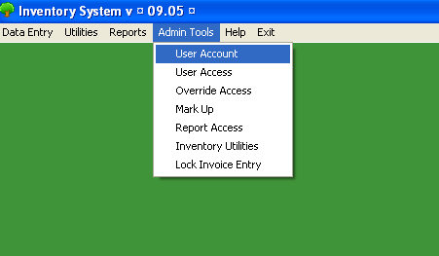**Figure 1.0**

**STEP 2:**

To Search the user name, you may type the employees name and click Search Button

To add access level, click Add Button, In User field Press Function key F5, see figure 3.0

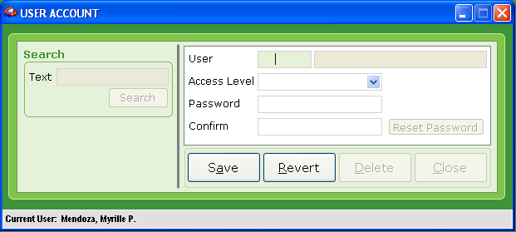**Figure 3.0**

**STEP 3:**

Search Employees Name in Search Text field and press Search Button.

Select the Employee you want to add access level by pressing Function key F5. See Figure 4.0

**Figure 4.0**

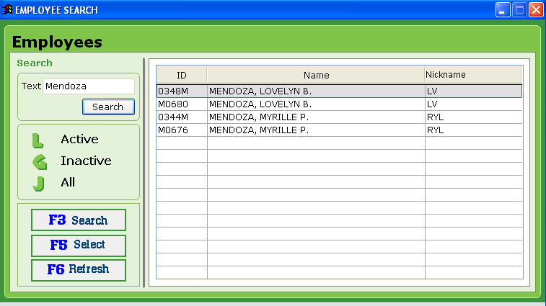

**STEP 4:**

To Add/Edit user account, select Access Level for user. Temporarily Supply Password using the users’ ID number and retype it in Confirm text field and click Save Button.

To reset the user account/password, press the Reset Password Button and then supply new password and retype the password in Confirm text field and click Save Button.

To delete access, Click Delete Button. See Figure 5.0

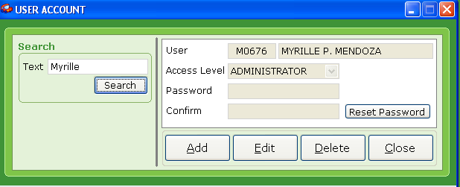**Figure 5.0**

**STEP 5:**

To add user access, Select the Admin Tools menu, and click User Access, see figure 6.0

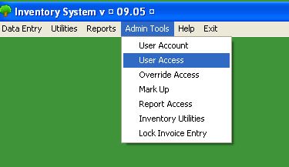**Figure 6.0**

**STEP 6:**

In User ID Text field you may type the company id number of the employee or press function F5 and search the employee name, press function key F5 to select.

Click Edit Access Button, then you may select the access based on your list for the user by ticking the box then click Save Button and Close. See figure 7.0

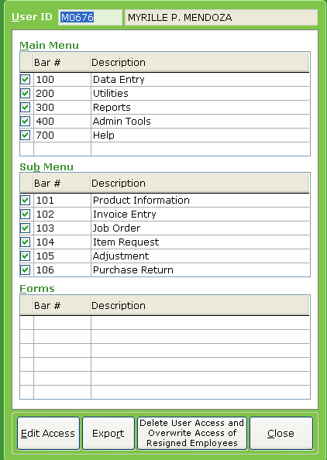**Figure 7.0**

**STEP 7:**

In User ID Text field you may type the company id number of the employee or press function F5 and search the employee name, press function key F5 to select.

In Report Form field, type 304 for report index.

Click Edit Access Button, then you may select the report based on your list for the user to view by ticking the box then click Save Button and Close. See figure 8.0

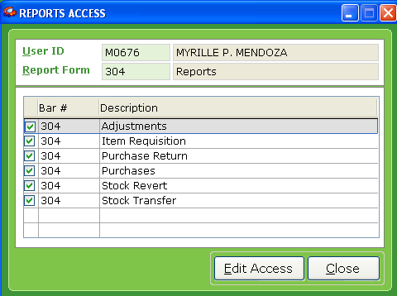**FIGURE 8.0**